Experiment 9
Name: Kaushik Kaundal | UID: 24BAI70562
Branch: B.E. CSE (AIML) | Section: 24AIT_KRG-G1
Semester: 4 | Date of Performance: 17.04.2026
Subject Name: Database Management System | Subject Code: 24CSH-298

AIM: To create and implement PL/SQL packages by developing a package specification and package body containing procedures and shared cursors, in order to achieve modular, reusable, and efficient database programming.
OBJECTIVES:
- To design and implement a PL/SQL package that includes procedures and shared cursors for structured and modular program development.
SOFTWARE REQUIREMENTS:
- Database Management System:
  - Oracle
- Database Administration Tool:
  - Oracle SQL Developer

PRACTICAL/EXPERIMENT STEPS:
- An employees table was created to store employee details such as ID, name, salary, and department.
- Sample records were inserted into the employees table for testing purposes.
- A PL/SQL package specification was created to declare procedures related to employee data.
- A package body was developed to implement the logic of the declared procedures.
- A shared cursor was defined inside the package to retrieve employee records efficiently.
- A procedure display_all_employees was implemented to display all employee details using the cursor.
- A procedure display_employee was created to fetch details of a specific employee using employee ID.
- The package procedures were executed to verify correct functionality and output.

PROCEDURE:
- Oracle SQL environment (SQL Developer / FreeSQL) was opened and the required database was selected.
- The employees table was created using the CREATE TABLE command.
- Sample data was inserted into the table using INSERT statements.
- A package specification was created using CREATE OR REPLACE PACKAGE to declare procedures.
- A package body was created using CREATE OR REPLACE PACKAGE BODY to define procedures and a shared cursor.
- Procedures were written to display all employees and to retrieve a specific employee by ID.
- The package procedures were executed using BEGIN ... END; blocks.
- The output was displayed using DBMS_OUTPUT.PUT_LINE and verified for correctness.

CODE:
CREATE TABLE employees (
emp_id NUMBER PRIMARY KEY,
emp_name VARCHAR2(50),
salary NUMBER,
department VARCHAR2(50)
);

INSERT INTO employees VALUES (101, 'Rahul', 50000, 'HR');
INSERT INTO employees VALUES (102, 'Anita', 60000, 'Finance');
INSERT INTO employees VALUES (103, 'Karan', 55000, 'IT');
INSERT INTO employees VALUES (104, 'Neha', 65000, 'Marketing');

COMMIT;

CREATE OR REPLACE PACKAGE emp_package AS
PROCEDURE display_all_employees;\
PROCEDURE display_employee(p_emp_id NUMBER);

END emp_package;
/

CREATE OR REPLACE PACKAGE BODY emp_package AS
CURSOR emp_cursor IS
SELECT emp_id, emp_name, salary, department
FROM employees;

PROCEDURE display_all_employees IS
BEGIN
FOR emp_rec IN emp_cursor LOOP
DBMS_OUTPUT.PUT_LINE(
emp_rec.emp_id || ' | ' ||
emp_rec.emp_name || ' | ' ||
emp_rec.salary || ' | ' ||
emp_rec.department
);
END LOOP;
END display_all_employees;

PROCEDURE display_employee(p_emp_id NUMBER) IS
v_emp employees%ROWTYPE;
BEGIN
SELECT * INTO v_emp
FROM employees
WHERE emp_id = p_emp_id;

DBMS_OUTPUT.PUT_LINE(
v_emp.emp_id || ' | ' ||
v_emp.emp_name || ' | ' ||
v_emp.salary || ' | ' ||
v_emp.department
);

EXCEPTION
WHEN NO_DATA_FOUND THEN
DBMS_OUTPUT.PUT_LINE('Employee not found.');
END display_employee;
END emp_package;
/

SET SERVEROUTPUT ON;

BEGIN
emp_package.display_all_employees;
END;
/

BEGIN
emp_package.display_employee(102);
END;
/

I/O ANALYSIS:
- Create a table
The employees table is successfully created with fields such as emp_id, emp_name, salary, and department. The emp_id is defined as a primary key, ensuring unique employee records.
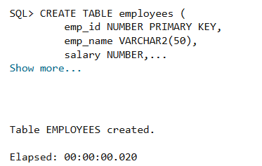
- Insert Records
Sample employee records are inserted into the table successfully. The table now contains multiple employee entries for testing the package procedures.
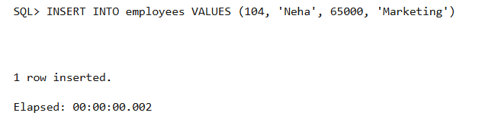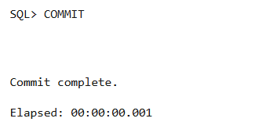

- Creating Package Specification
The package specification emp_package is created successfully. It declares procedures to display all employees and to fetch a specific employee using ID.
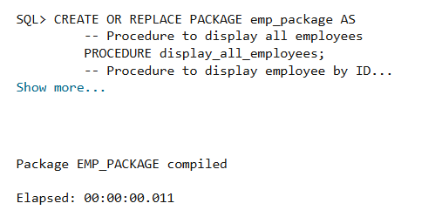

- Creating Package Body with Shared Cursor
The package body is created successfully. A shared cursor (emp_cursor) is defined to retrieve employee records efficiently and is used across procedures.

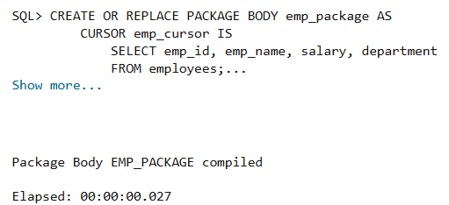
- Display Employee Details (All & Specific)
The procedures display_all_employees and display_employee are executed successfully. All employee records are displayed using the shared cursor, and specific employee details are retrieved correctly using employee ID.
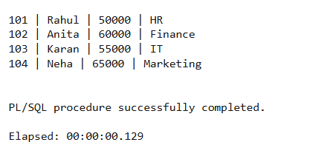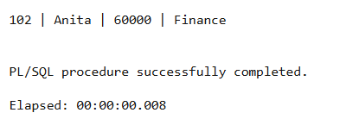

LEARNING OUTCOMES:
    - Understood the concept and structure of PL/SQL packages.
    - Differentiated between package specification and package body.
    - Developed packages containing procedures and shared cursors.
    - Wrote modular and reusable PL/SQL code.
    - Applied package development techniques used in organizations such as Rippling, Oracle, SAP, and PayPal.

